

*Journal Geophysical Research*

Supporting Information for

**Hydrologically-induced karst deformation: insights from GPS measurements in the Adria-Eurasia plate boundary zone**

E. Serpelloni 1*, F. Pintori 2, A. Gualandi 3, Scoccimarro 4, A. Cavaliere 5, L. Anderlini 1, M.E. Belardinelli 2, M. Todesco 5

1 Istituto Nazionale di Geofisica e Vulcanologia, Centro Nazionale Terremoti

2 Dipartimento di Fisica e Astronomia, Settore di Geofisica, Università di Bologna

3 Jet Propulsion Laboratory, California Institute of Technology

4 Fondazione Centro Euro-Mediterraneo sui Cambiamenti Climatici, Bologna

5 Istituto Nazionale di Geofisica e Vulcanologia, Sezione di Bologna

**Contents of this file**

Text S1 to S3

Figures S1 to S12

Caption for Dataset S1 and Dataset S2

**Introduction**

This supporting information provides additional description about the GPS data processing (Text S1), the comparison between different gridded precipitation datasets (Text S2) and the tensile dislocation model discussed in Section 6 (Text S3).

This file includes additional figures discussed in the main-text, showing the distribution and names of the GPS stations used (Fig. S1), the spatial response for IC1, IC3, IC4 and IC5 for the stations with Signal to Noise Ratio (SNR) > 1 (Fig. S2), the temporal evolution and spatial response of IC2 as obtained excluding CANV from the analysis (Fig. S3), the comparisons between displacements associated with the seasonal components (IC1 and IC3 in Fig. S4) and surface hydrology mass loading models (Fig. S5 and Fig. S6), the comparison between different gridded datasets and pluviometric records (Figs S7, S8, S9, S10), discussed in Section 3.2 and Text S2, and the determination of the equivalent tensile fracture geometry discussed in Section 4 (Fig. S12).

The Dataset captions describe the de-trended time-series used as input of the vbICA analysis, provided as ASCII files (Dataset 1), and plots, provided as PDF files, of the observed and reconstructed time-series (Dataset 2) for all the GPS stations included in the ICA analysis.

Text S1. GPS Data Processing

The position time-series have been obtained adopting a three-step procedure approach, as in Serpelloni et al. (2006), that includes: 1) raw phase data reduction, 2) combination of loosely constrained network solutions and reference frame definition and 3) time-series analysis, including velocity estimates and spatial filtering of common mode errors.

The raw GPS observables have been analyzed using the 10.6 version of the GAMIT/GLOBK package (Herring et al., 2015) adopting standards defined in the framework of the IGS “Repro2 campaign” (http://acc.igs.org/reprocess2.html). The GAMIT software is used to estimate station positions, atmospheric delays, satellite orbits, and Earth orientation parameters from ionosphere-free linear combination GPS phase observables using double differencing techniques to eliminate phase biases caused by drifts in the satellite and receiver clock oscillators. GPS pseudo-range observables are used to constrain clock timing offsets and to improve automated editing of the phase data, assisting in the resolution of integer phase ambiguities. GPS phase data are weighted according to an elevation-angle-dependent error model (Herring et al., 2015) using an iterative analysis procedure whereby the elevation dependence is determined from the observed scatter of phase residuals.

In this analysis the satellites orbit parameters are fixed to the IGS final products. We use the IGS absolute antenna phase center model for both satellite and ground-based antennas, which improves the accuracy of estimates for the vertical components of site position by mitigating reference frame scale and atmospheric mapping function errors (e.g., Schmid et al., 2005, 2007). While the first-order ionospheric delay is eliminated by the ionosphere-free linear combination, the second-order ionospheric corrections are applied based on the formulation of Petrie et al. (2010), using IONEX files from the Center for Orbit Determination in Europe (CODE). The tropospheric delay is modeled as piecewise linear model and estimated using the Vienna Mapping Function 1 (VMF1; Boehm et al., 2006) with a 10° cutoff. We use the Global Pressure and Temperature 2 (GPT2; Lagler et al., 2013) model to provide a priori hydrostatic delays. The pole tide was also corrected in GAMIT by IERS standards. The Earth Orientation Parameters (EOP) are tightly constrained to priori values obtained from IERS Bulletin B. Non-tidal atmospheric loading and ocean tidal loading are corrected using MIT filtered atmospheric displacements files (available at ftp://everest.mit.edu/pub/GRIDS) and the FES2004 (Lyard et al., 2006) model, respectively. The International Earth Rotation Service (IERS) 2003 model for diurnal and semi-diurnal solid Earth tides was set.

Because of the large number of stations included in our Euro-Mediterranean GPS processing (~3000), this step is performed for several sub-networks, each made by <50 stations, with each sub-network sharing a set of high-quality IGS stations, which are used as tie-stations in the combination step.

In the second step we use the ST_FILTER program of the QOCA software (http://qoca.jpl.nasa.gov), which adopts a Kalman filter estimation algorithm (Dong et al., 1998, 2002), to combine all the daily loosely constrained solutions with the global solution of the IGS network made available by MIT (http://sopac.ucsd.edu), and simultaneously realize a global reference frame by applying generalized constraints (Dong et al., 1998). Specifically, we define the reference frame by minimizing the velocities of the IGS core stations (http://igscb.jpl.nasa.gov), while estimating a seven-parameter transformation with respect to the GPS realization of the ITRF2008 frame (Altamimi et al., 2011), i.e., the IGb08 reference frame.

In the third step we analyze the position time series in order to estimate and correct offsets due to stations equipment changes, while simultaneously estimating annual and semi-annual periodic signals and a linear velocity term. In this analysis we retain only data from GPS stations with an observation period longer than 2.5 years, as shorter intervals may result in biased estimates of linear velocities (Blewitt and Lavallee, 2002). The model derived from the combination of these signals is then subtracted from the position time series in order to get the residual positions. The residual time-series are then used to estimate the Common Mode Error (CME) performing a Principal Component Analysis (PCA), as described in Dong et al. (2006). The PCA is performed at a continental-scale, over the same area used by Serpelloni et al. (2013), and the first two PCs are here considered as CME. This prevents the removal of the eventual more localized signals of geophysical interests recorded by the GPS stations in the study region, since the PCA detects the signals common to a much larger region. As a result, after removing the CME, the typical repeatability in our analysis is ~1 mm for the horizontal components, and ~3 mm for the vertical component, with a 30% gain in the daily repeatability and a significant improvement of the signal to noise ratio. After the spatial filtering, the estimated seasonal motions are added back to the filtered time-series, obtaining position time series with a reduced scatter around the adopted model.

Text S2. Comparison between gridded precipitation datasets

The study region is covered by three different gridded datasets of meteo-climatic data (including air temperature, pressure and precipitation): 1) the E-OBS gridded values from ECA&D data (Haylock et al., 2008), 2) the Alpine Precipitation Grid Dataset from the Federal Office of Meteorology and Climatology MeteoSwiss (http://www.euro4m.eu/datasets.html) and 3) the Tropical Rainfall Measuring Mission (TRMM) from NASA (https://trmm.gsfc.nasa.gov). While the TRMM dataset is based on satellite data, providing intensive and globally distributed observations, the first two gridded datasets are based on ground pluviometric stations, with the second one based on a much larger and denser network of stations. However, the Alpine Precipitation Grid Dataset currently covers the 1971-2008, so it is only very partially covering the time-period studied in this work.

We have first compared the precipitation values in the three gridded datasets for an area between longitude 10.5-16°E and latitude 45-47°N. Fig. S7 highlights the agreement between the three gridded datasets, showing that the correlation between the curves of cumulated precipitation obtained from the three gridded datasets remain high (>0.8), independently from the number of days used to calculate the cumulative precipitation. Fig. S8 displays the cumulative precipitation as a function of time (an accumulation period of 240 is assumed, which realizes the highest correlation value in Fig. 8) obtained using the three gridded datasets and considering the same area as in Fig. S7. A substantial agreement between the datasets is evident in Fig. S8.

We have then compared E-OBS precipitation data with data from pluviometric stations in the Southern Alps. Fig. S9 displays the correlation coefficient calculated comparing the cumulated precipitation curves obtained from the measurements at three pluviometric stations located near the GPS stations of CANV, BOSC and TAMB (see Fig. 6) with gridded values in the corresponding cells from the E-OBS dataset. Fig. S9 shows that the correlation is overall high independently from the number of days used to calculate the cumulative precipitation. Considering a number of 240 days of cumulated precipitation, also the correlation between V2 and the precipitation data measured at pluviometric stations near the three GPS stations is overall high (Fig. S10).

Text S3. The equivalent tensile fracture parameters estimate

The displacements associated with the IC2 for the area 2 (see Fig. 9) were modeled using a rectangular tensile dislocation (Okada, 1985) or a tensile fracture modeled with a boundary element approach in an elastic half space whose geometry has been estimated from the measured horizontal displacements in the T1 time intervals (Fig. 9A). By fixing the dip angle at 90°, the mid-point along strike (Lon. = 12.25, Lat. = 46.07) and the top depth at 0 km (free surface), while allowing the other parameters (strike, length and width) to vary within larger bounds, we used a simulated annealing approach (Cervelli et al., 2001) to estimate the optimal parameters. The bounds for the length, strike and width are 40-80 km, 50-80 °N and 0.1-1.5 km, respectively. In order to define error bounds on the length, strike and width, we run the inversion 2000 times and analyze the parameter distributions. Fig. S12 shows the frequency histograms of the modeled parameters, where the best values, used to estimate the opening and pressure changes that best fit the measured displacements (see Section 6), are defined as the median value of each distribution (red bars) and the associated uncertainties, at the 68% confidence level, are determined from 16th and 84th percentile bounds (green bars).

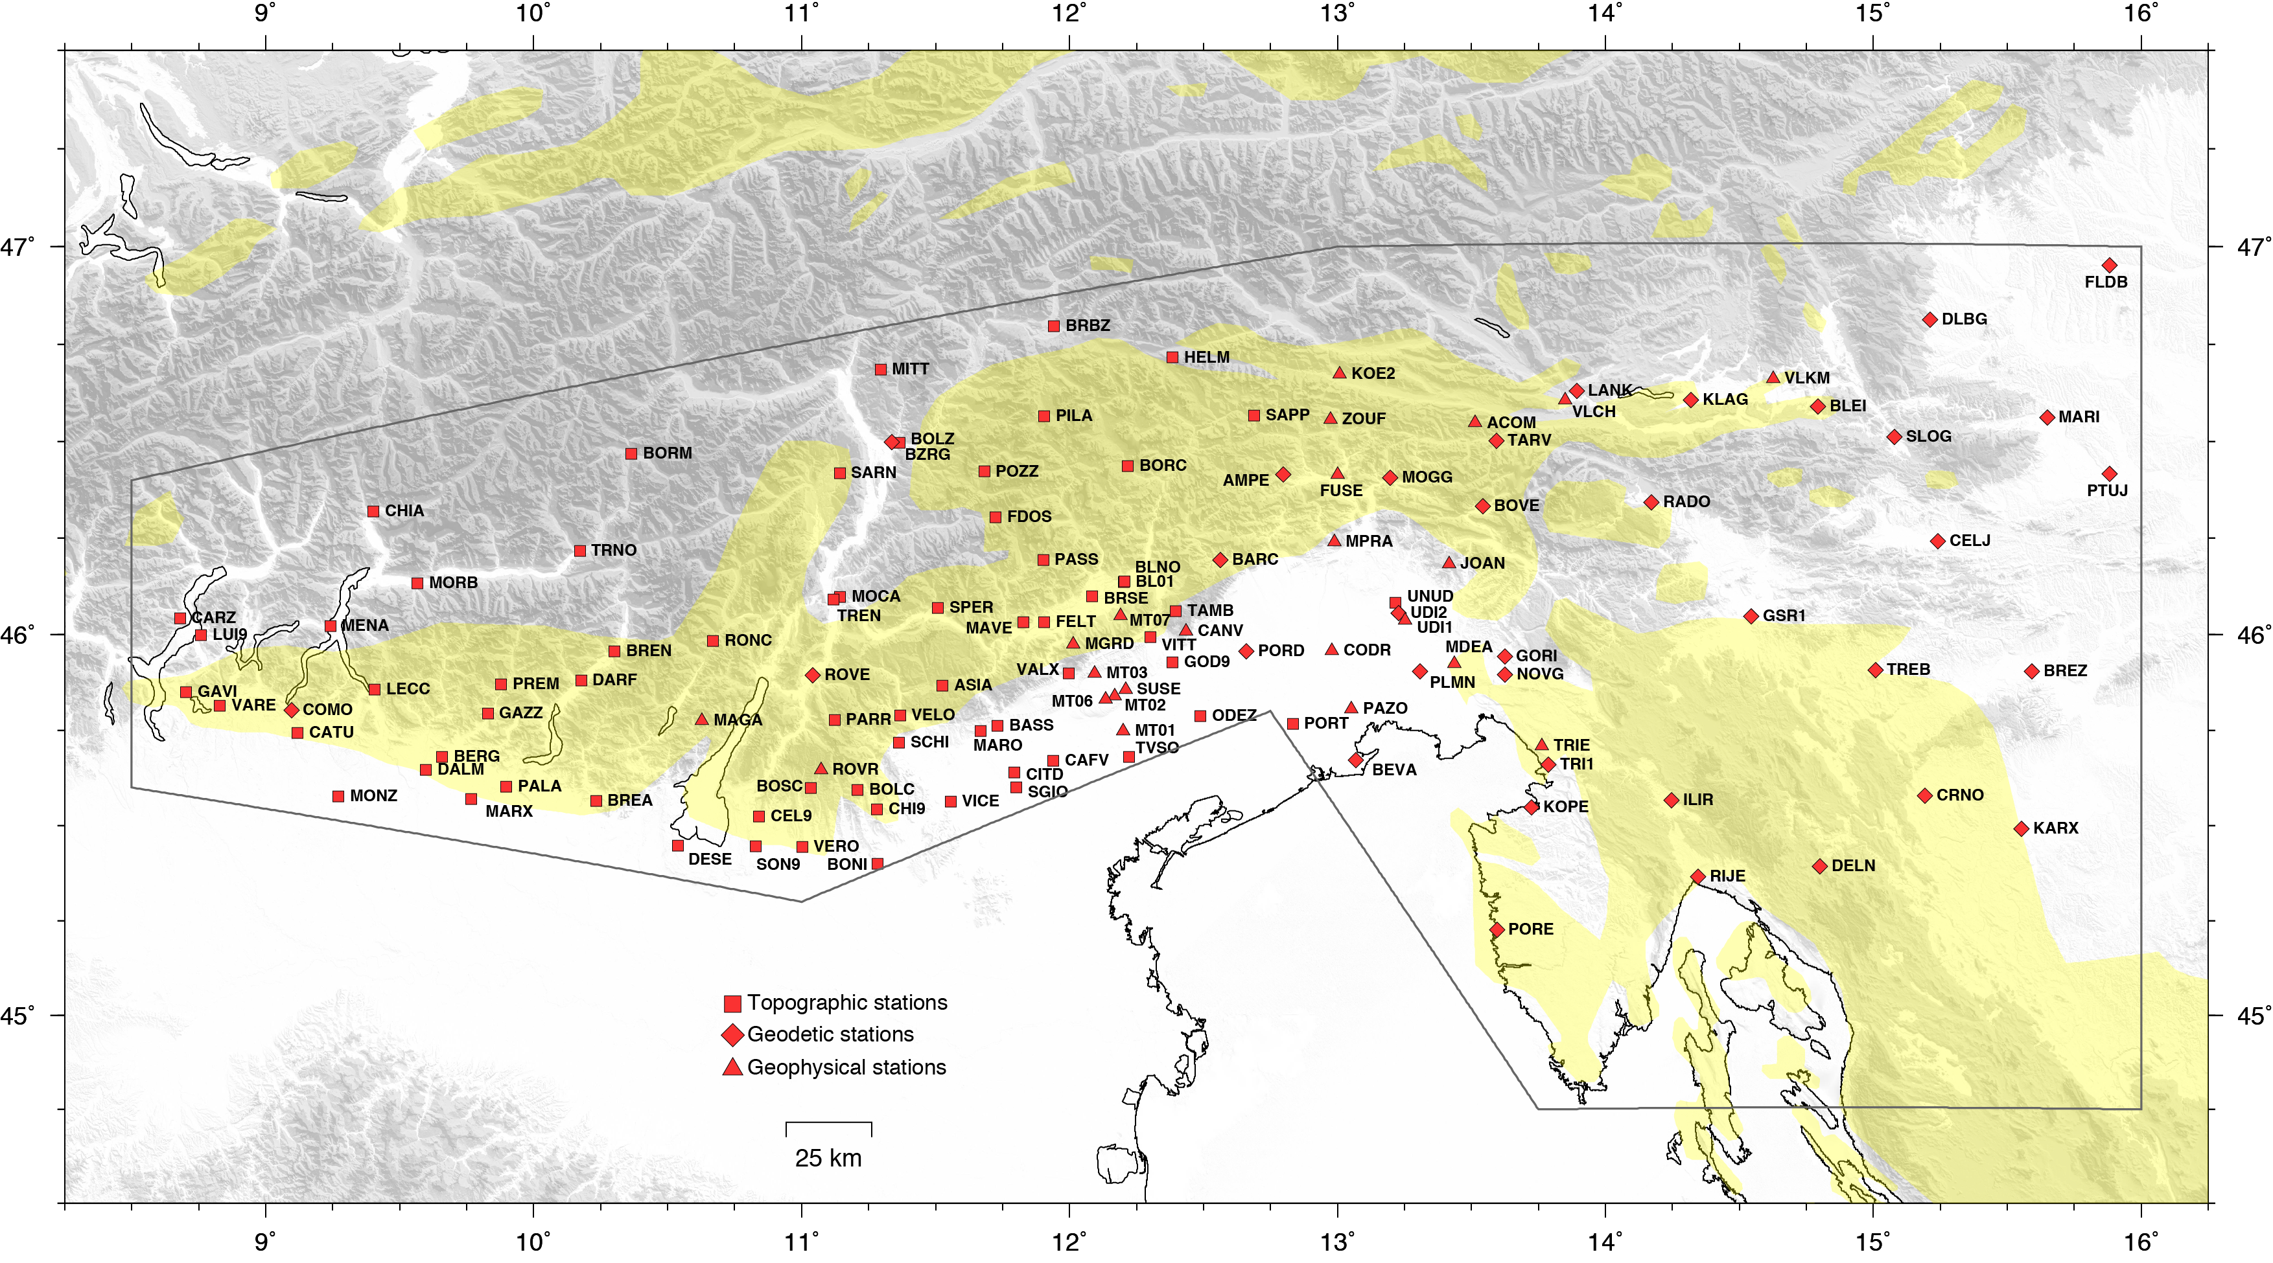

**Figure S1**. Map and names of the continuous GPS stations analyzed in this work. The red square, hexagon and triangles indicate stations belonging to topographic, geodetic and geophysical networks (following Serpelloni et al., 2013).

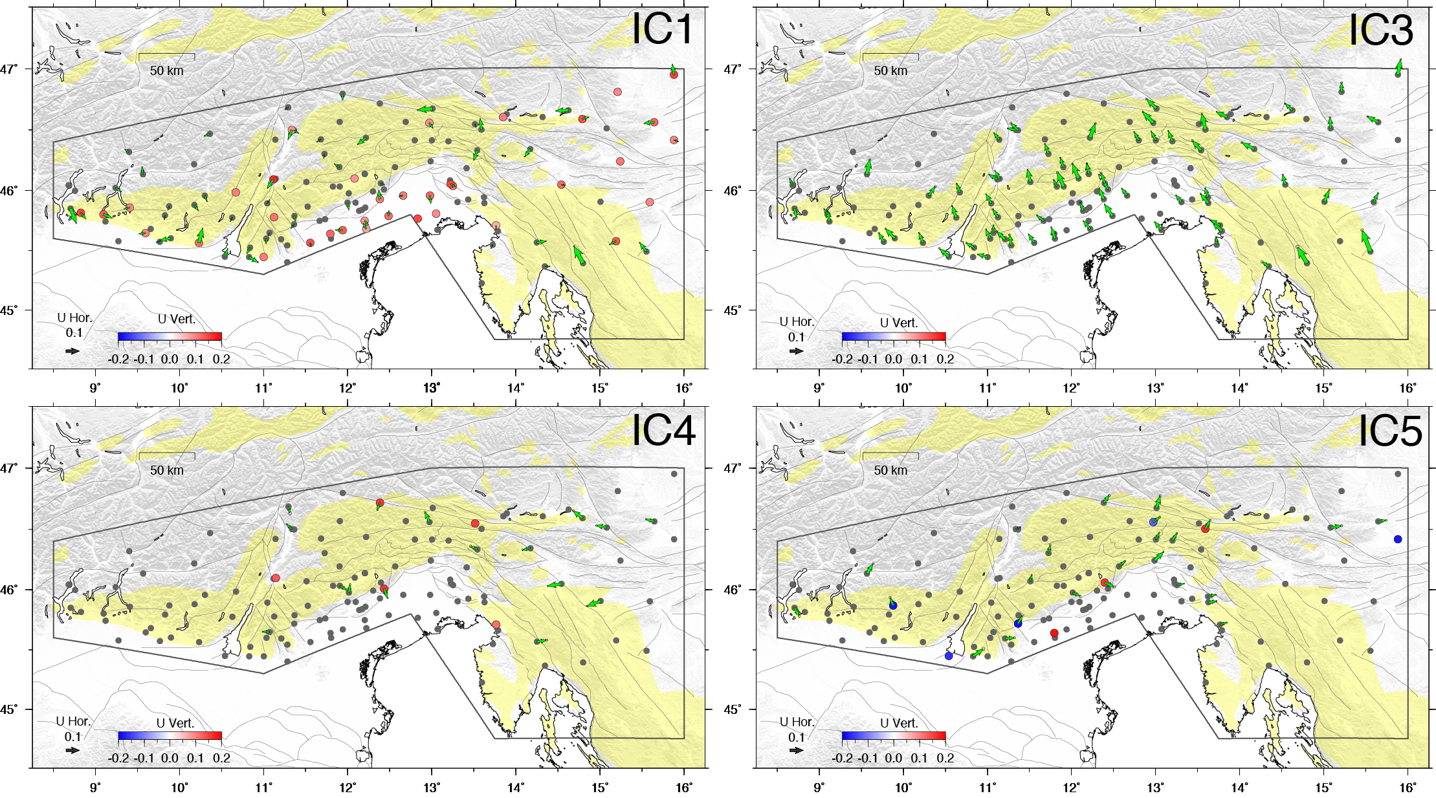

**Figure S2.** Map views of the spatial response, U, for IC1, IC3, IC4 and IC5, where the green arrows show the horizontal response and the color scale refers to the vertical response, respectively, only for stations that have a Signal-to-Noise-Ratio (SNR)>1 in at least one component. See Fig. 6 for IC2.

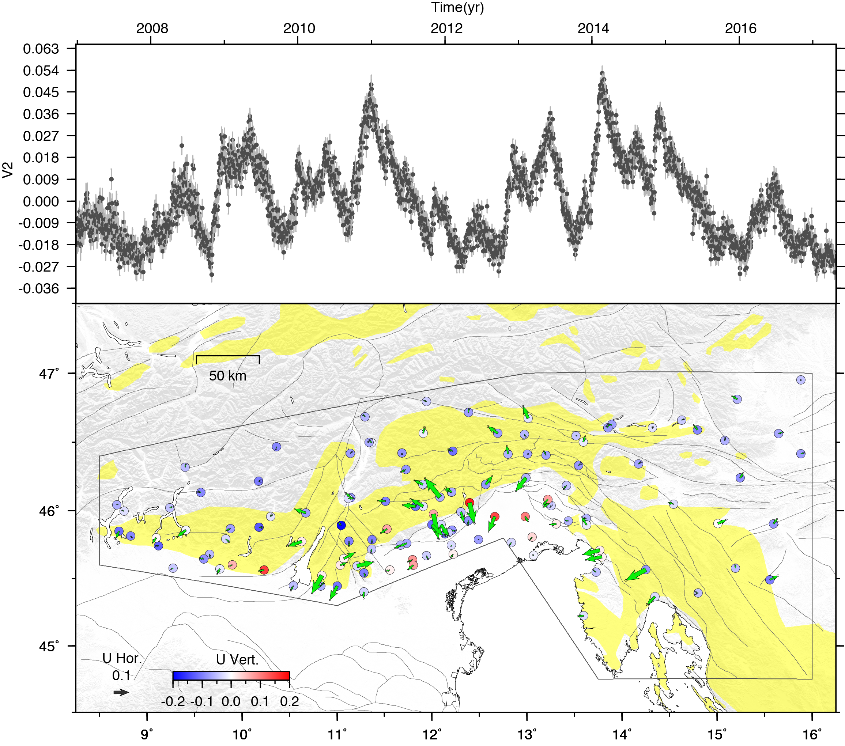

**Figure S3.** Temporal evolution (V2) and spatial response (as in Fig. S2) for IC2, obtained excluding the station CANV from the vbICA analysis.

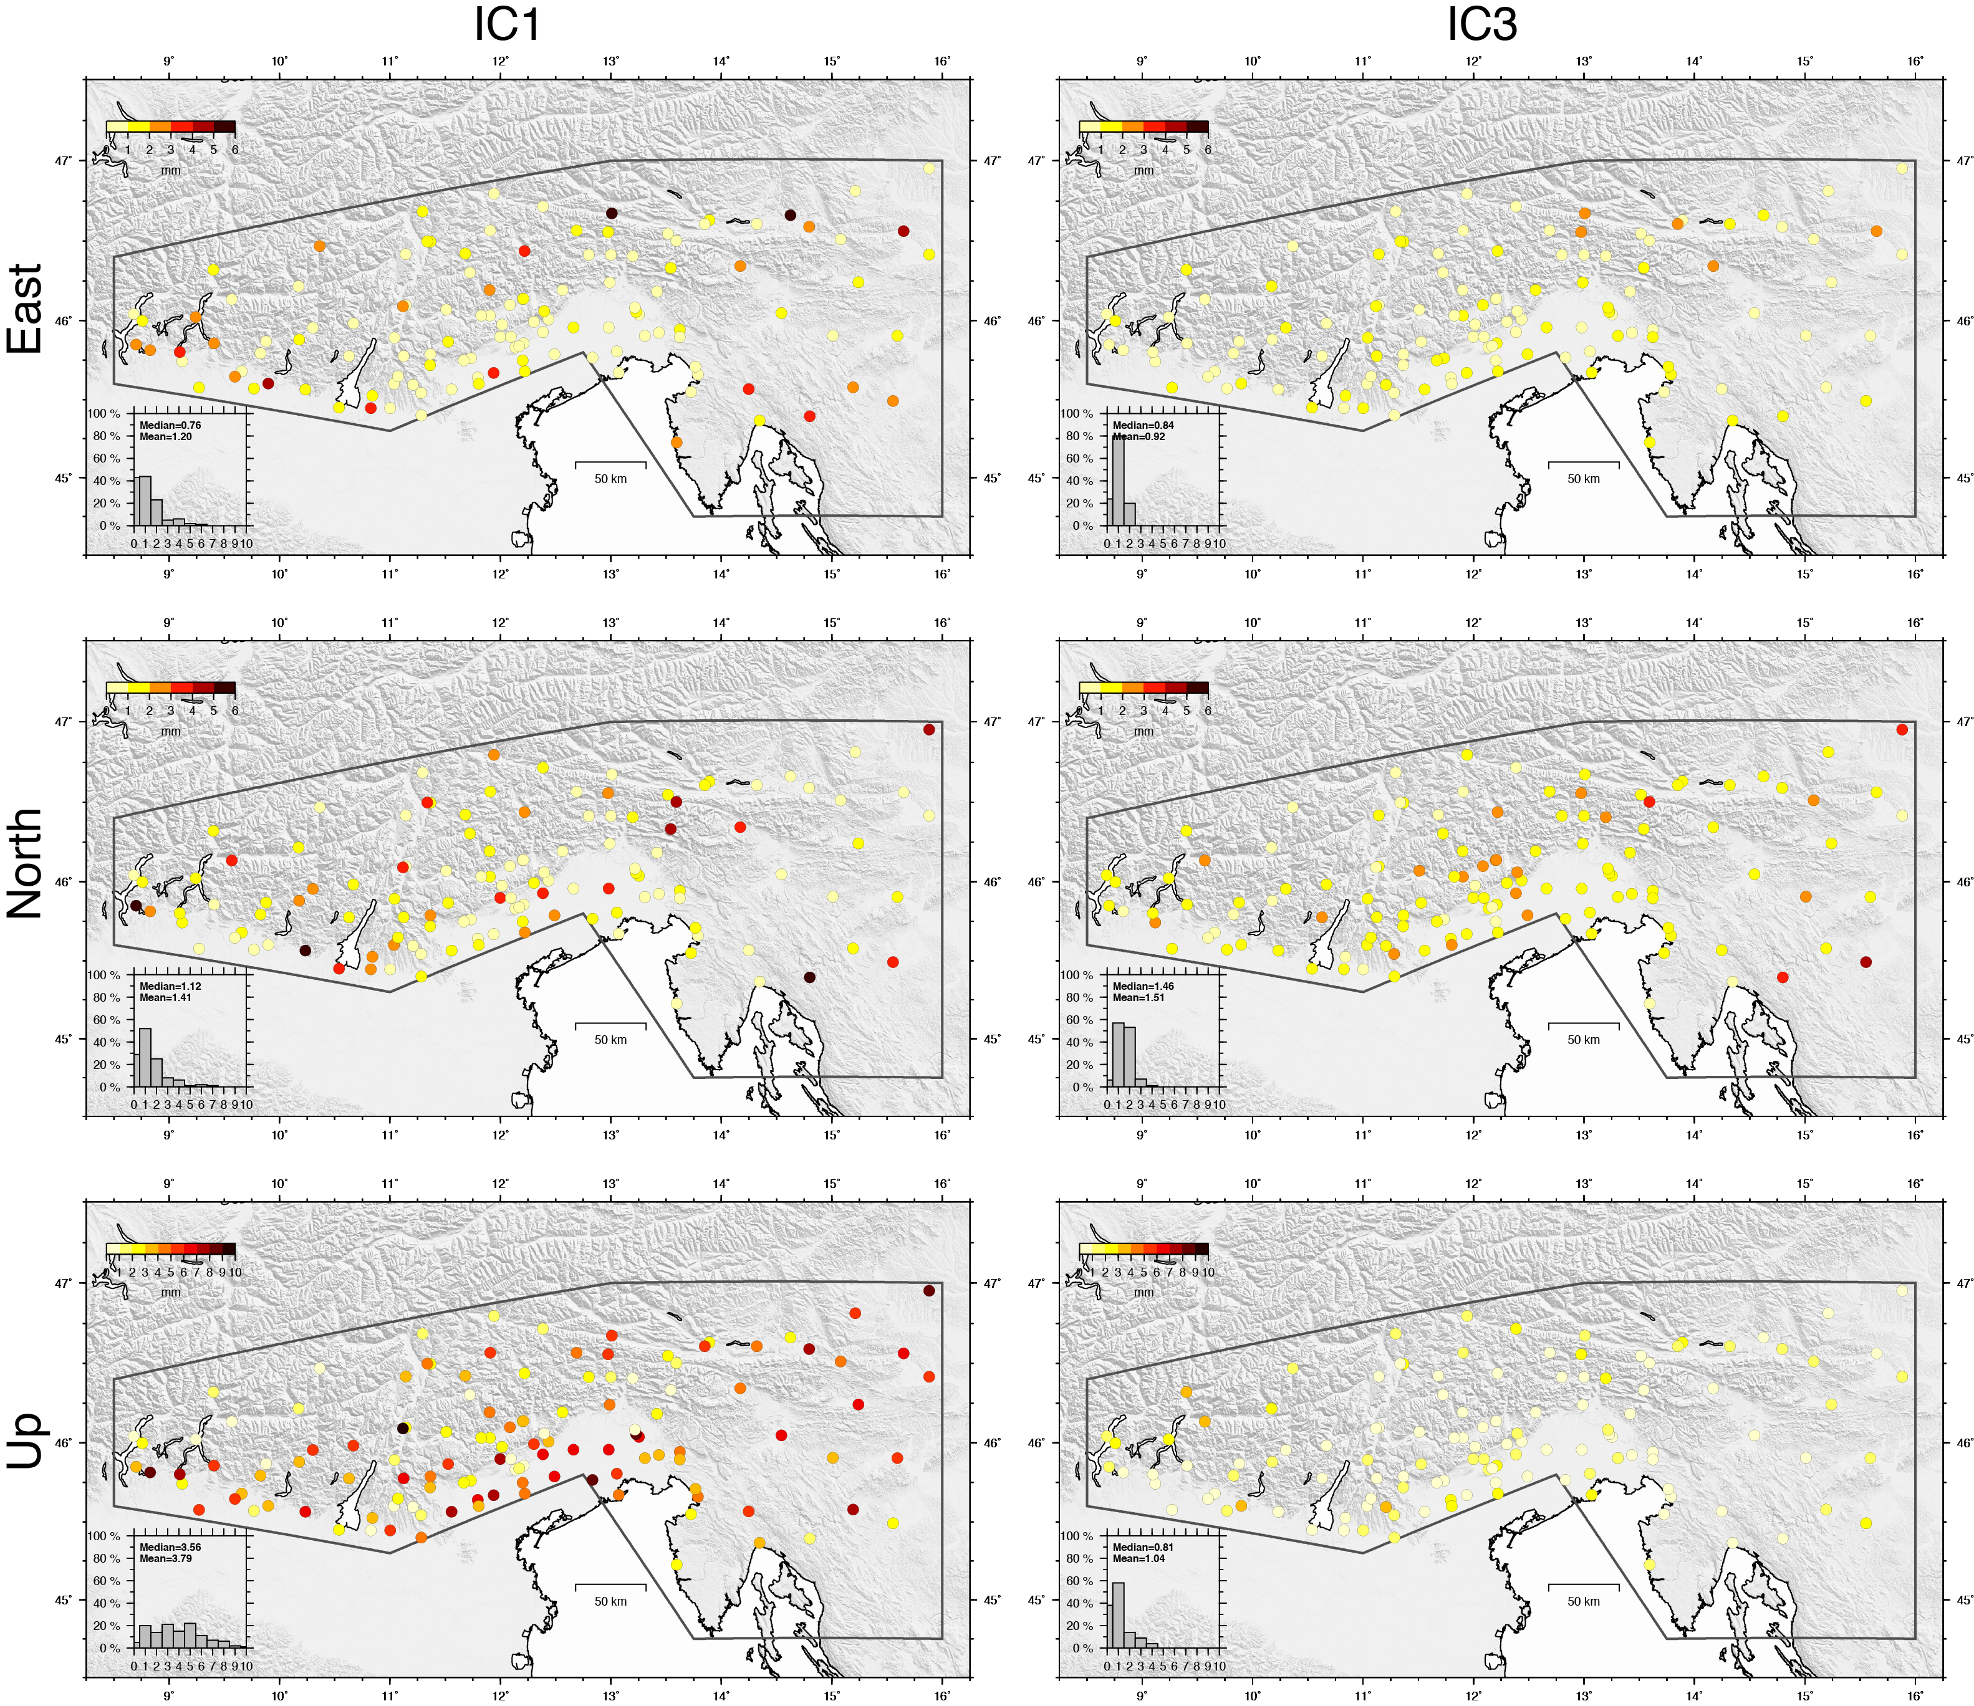

**Figure S4.** Map views of the amplitudes (color circles) of seasonal signals (IC1 and IC3) in the east, north and vertical components. The histograms show the frequency distribution of the values, with mean and median values in mm.

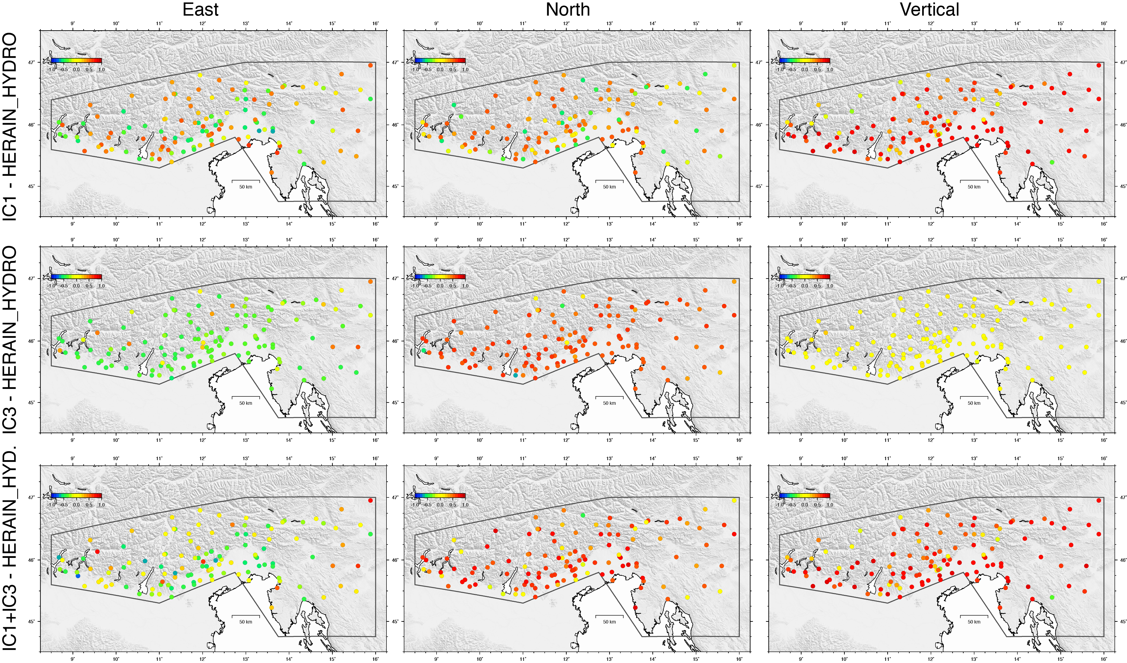

**Figure S5.** Map views of the Lin’s concordance correlation coefficient (colored circles), with values between -1 (blue) and +1 (red), obtained comparing the displacements associated with IC1, IC3 and IC1+IC3, for the east, north and vertical components, with displacements due to the redistribution of fluids at the Earth’s surface estimated using the ERA-interim global reanalysis model provided by http://loading.u-strasbg.fr.

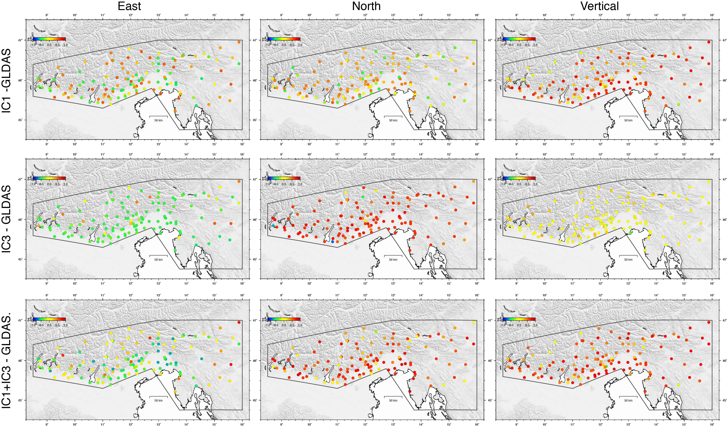

**Figure S6.** Map views of the Lin’s concordance correlation coefficient (colored circles), with values between -1 (blue) and +1 (red), obtained comparing the displacements associated with IC1, IC3 and IC1+IC3, for the east, north and vertical components, with displacements due to the redistribution of fluids at the Earth’s surface estimated using the GLDAS global reanalysis model provided by http://loading.u-strasbg.fr.

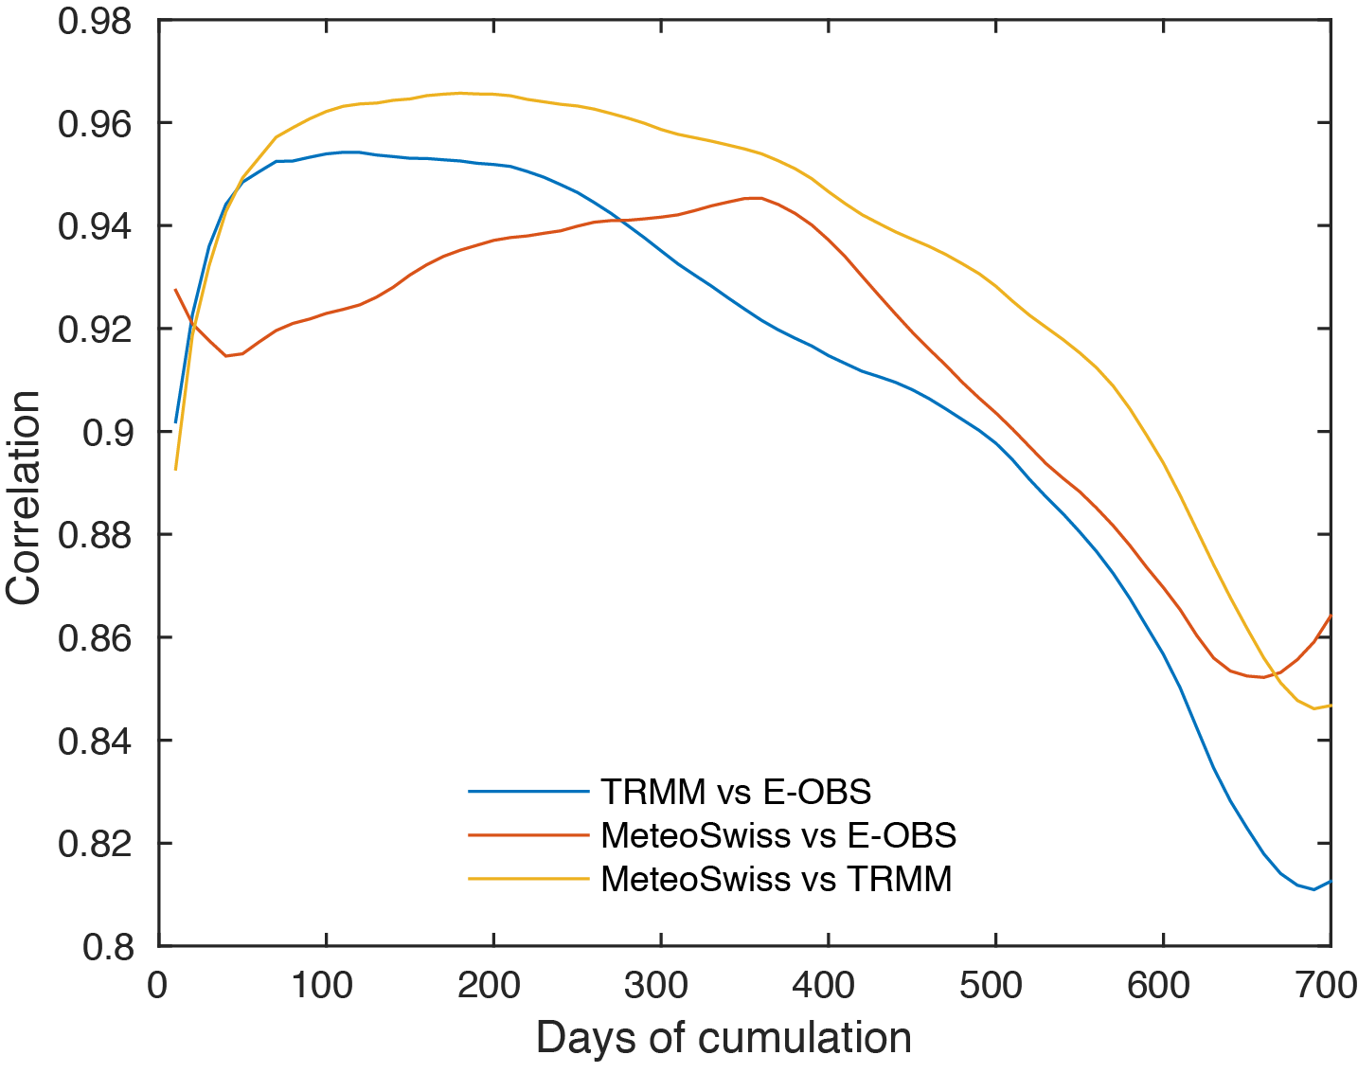

Figure S7. Correlation between the curves of cumulated precipitation as a function of the number of days used to calculate the cumulative precipitation value, obtained using the three different gridded datasets for the area between longitude 10.5-16°E and latitude 45-47°N.

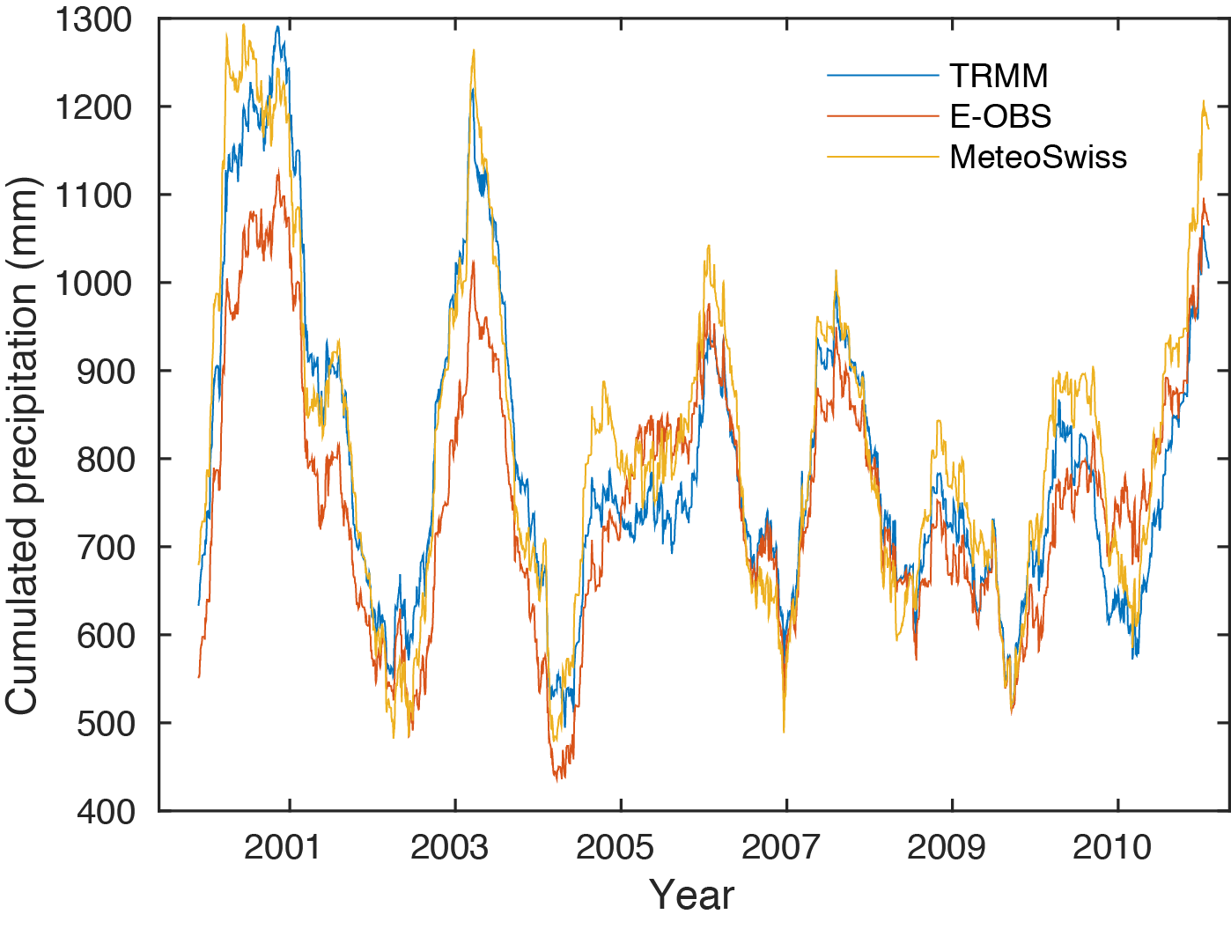

**Figure S8.** Curves of cumulated precipitation obtained considering 240 days of cumulative precipitation for the three different gridded datasets available in the area between longitude 10.5-16°E and latitude 45-47°N (same as Fig. S7).

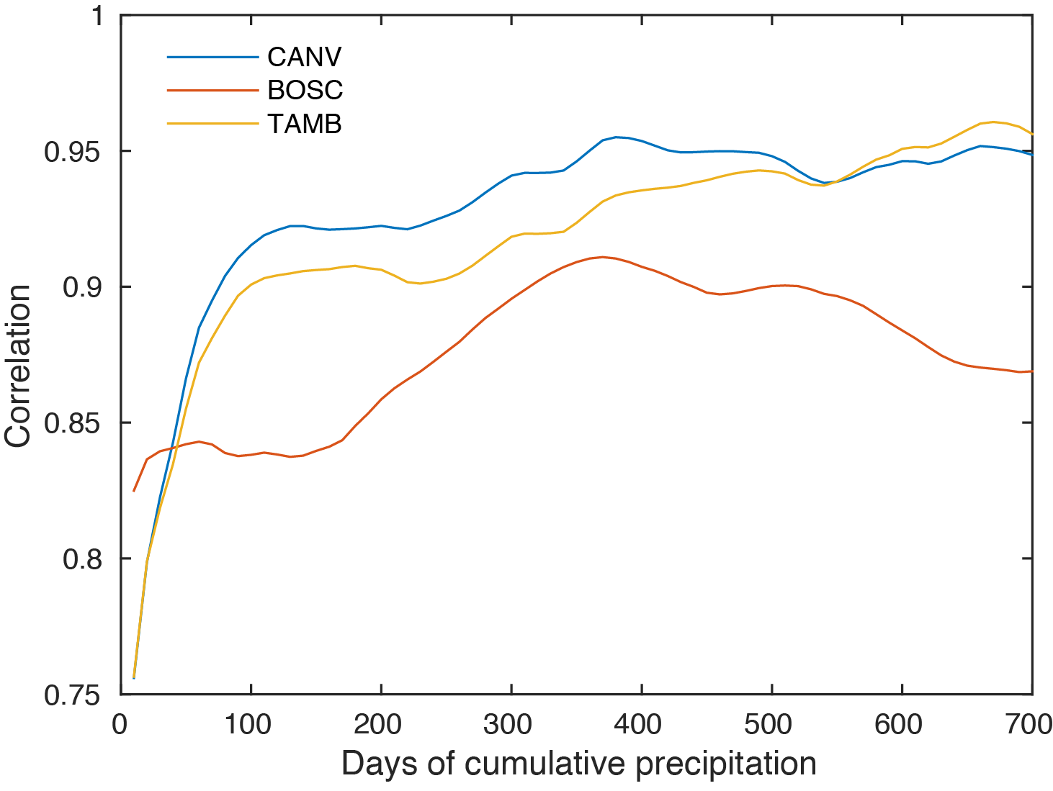

**Figure S9**. Correlation between the curves of cumulative precipitation as a function of the number of days considered to calculate the cumulative precipitation value obtained from data recorded at the single pluviometric stations located near three GPS stations used in this work (CANV in blue, BOSC in red and TAMB in yellow) and from the corresponding E-OBS grid cells where the pluviometers are located.

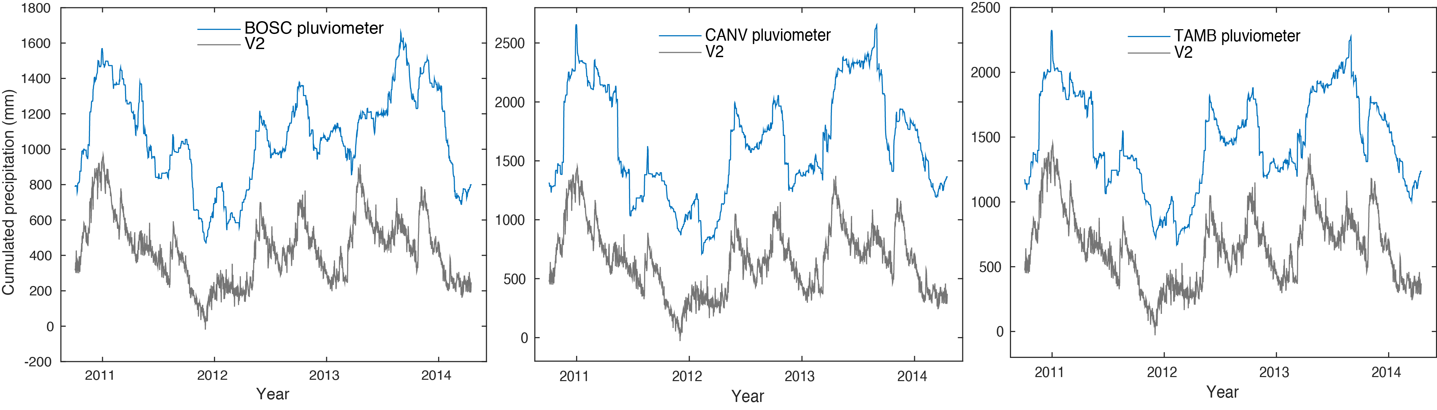

**Figure S10**. Comparison between V2 (in gray) and the curve of cumulated precipitation obtained considering 240 days of cumulative data for the pluviometers located near the GPS stations BOSC (left), CANV (center) and TAMB (right), in blue.

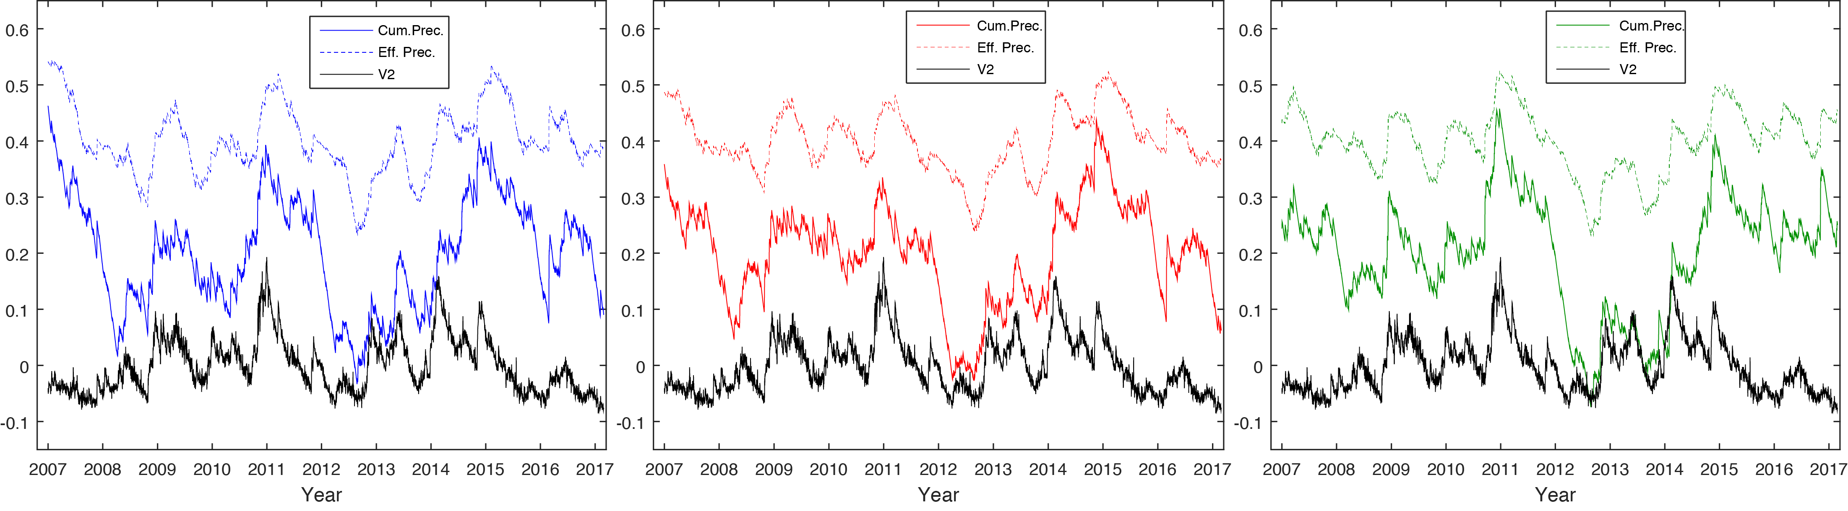

**Figure S11**. Comparison between V2 (in black) and curves of cumulative (over the 2007-2017 time-interval) and de-trended precipitation accounting (dashed lines) or not (solid lines) for the evapotranspiration (ET) component, where the blue, red and green curves refer to the three areas described in Fig. 8.

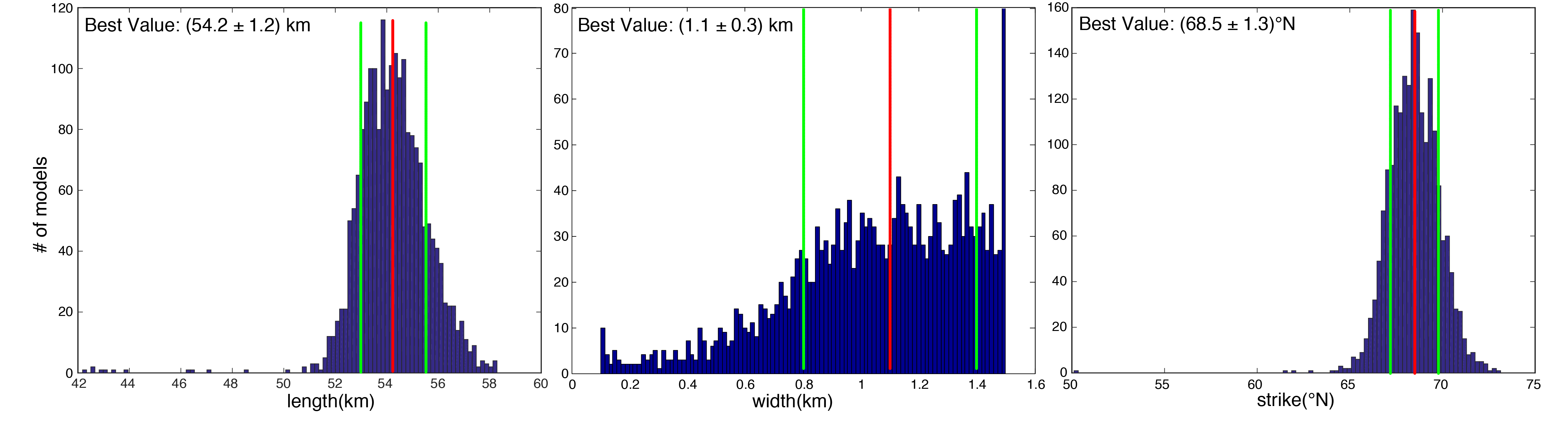

**Figure S12**. Frequency distribution of length, width and strike values of the tensile dislocation obtained from 2000 simulated annealing runs. The red and green lines show the median value and the 16th and 84th percentile confidence levels.

Dataset S1. ASCII files reporting the (de-trended) position time-series of all stations used as input of the vbICA analysis described in Section 4.1. The columns are: Time, E, N, Se, Sn, Ren, U, Su, Reu, Rnu, site, long, lati, representing, respectively, epoch (in decimal years), displacement in the East component (in mm), displacement in the North component (in mm), uncertainty (one standard deviation) of the East component (in mm), uncertainty (one standard deviation) of the North component (in mm), correlation between the East and North components, displacement in the Up component (in mm), uncertainty (one standard deviation) of the Up component (in mm), correlation between the East and Up components, correlation between the North and Up components, Station ID (four letters), Longitude of the station (°), Latitude of the station (°).

Dataset S2. PDF plots of the observed de-trended position time-series (blue dots with one standard deviation error bars in grey) and reconstructed time-series (red lines) for the GPS stations included in the vbICA analysis (see Fig.1). The green lines indicate the annual+semiannual model (see main-text) and the dark grey lines indicate surface hydrological loading displacements estimated from the ERA-interim (ECMWF Reanalysis) model (see Section 4.2)

References

1. Altamimi, Z., X. Collilieux, and L. Métivier (2011), ITRF2008: an improved solution of the international terrestrial reference frame, J Geodesy, 85(8), 457–473, doi:10.1007/s00190-011-0444-4.
2. Blewitt, G., and D. Lavallee (2002), Effect of annual signals on geodetic velocity, J. Geophys. Res., 107(B7), 2145, doi:10.1029/2001JB000570.
3. Boehm, J., Heinkelmann, R.; Schuh, H. (2007). Short note: A global model of pressure and temperature for geodetic  applications, *J. Geod., 81*, 679–683,  https://doi.org/10.1007/s00190-007-0135-3.
4. Boehm, J.; Werl, B.; Schuh, H. (2006). Troposphere mapping functions for GPS and very long baseline interferometry  from European Centre for Medium-Range Weather Forecasts operational analysis data, *J. Geophys. Res.,* *111*, doi: 10.1029/2005JB003629.

Brunetti, M., M. Maugeri, T. Nanni, I. Auer, R. Böhm, and W. Schöner (2006), Precipitation variability and changes in the greater Alpine region over the 1800–2003 period, *J Geophys Res*, *111*(D11), D11107–29, doi:10.1029/2005JD006674.

1. Cervelli, P., Murray, M.H., Segall, P., Aoki, Y. & Kato, T., 2001. Estimating source parameters from deformation data, with an application to the March 1997 earthquake swarm off the Izu Peninsula, Japan, *J. Geophys. Res.*, 106(B6), 11 217–11 237, doi: 10.1029/2000JB900399.
2. Dong, D., P. Fang, Y. Bock, F. Webb, L. Prawirodirdjo, S. Kedar, and P. Jamason (2006), Spatiotemporal filtering using principal component analysis and Karhunen-Loeve expansion approaches for regional GPS network analysis, J. Geophys. Res., 111, B03405, doi:10.1029/ 2005JB003806.
3. Dong, D., P. Fang, Y. Bock, M. Cheng, and S. Miyazaki (2002), Anatomy of apparent seasonal variations from GPS-derived site position time series, J. Geophys. Res., 107(B4), 2075, doi:10.1029/2001JB000573.
4. Dong, D., T. Herring, and R. King (1998), Estimating regional deformation from a combination of space and terrestrial geodetic data, J. Geodesy, 72(4), 200–214, https://doi.org/10.1007/s001900050161.

Haylock, M. R., N. Hofstra, A. M. G. Klein Tank, E. J. Klok, P. D. Jones, and M. New (2008), A European daily high-resolution gridded data set of surface temperature and precipitation for 1950–2006, J. Geophys. Res., 113, D20119, doi:10.1029/2008JD010201.

1. Herring, T. A., R. W. King, M. A. Floyd, and S. C. McClusky (2015), Introduction to GAMIT/GLOBK, Release 10.6. [Available at http://www-gpsg.mit.edu/~simon/gtgk/Intro_GG.pdf].
2. Lagler, K., M. Schindelegger, J. Böhm, H. Krásná, and T. Nilsson (2013), GPT2: Empirical slant delay model for radio space geodetic techniques, Geophys. Res. Lett., 40, 1069–1073, doi:10.1002/grl.50288.
3. Longuevergne, L., N. Florsch, F. Boudin, L. Oudin, and C. Camerlynck (2009), Tilt and strain deformation induced by hydrologically active natural fractures: application to the tiltmeters installed in Sainte-Croix-aux-Mines observatory (France), *Geophysical Journal International*, *178*(2), 667–677, doi:10.1111/j.1365-246X.2009.04197.x.
4. Lyard, F., F. Lefevre, T. Letellier, and O. Francis (2006), Modelling the global ocean tides: Modern insights from FES2004, Ocean Dynam., 56, 394–415, https://doi.org/10.1007/s10236-006-0086-x.

Okada, Y. (1985), Surface deformation to shear and tensile faults in a halfspace, Bull. Seismol. Soc. Am., 75, 1135–1154.

1. Petrie, E.J.; King, M.A.; Moore, P.; Lavallée, D.A. Higher-order ionospheric effects on the GPS reference frame and velocities. J. Geophys. Res. Solid Earth 2010, 115, doi: 10.1029/2009JB006677.
2. Schmid, R., M. Rothacher, D. Thaller, and P. Steigenberger (2005), Absolute phase center corrections of satellite and receiver antennas, *GPS Solut*, *9*(4), 283–293, doi:10.1007/s10291-005-0134-x.
3. Schmid, R., P. Steigenberger, G. Gendt, M. Ge, and M. Rothacher (2007), Generation of a consistent absolute phase-center correction model for GPS receiver and satellite antennas, *J Geodesy*, *81*(12), 781–798, doi:10.1007/s00190-007-0148-y.
4. Serpelloni, E., C. Faccenna, G. Spada, D. Dong, and S. D. P. Williams (2013), Vertical GPS ground motion rates in the Euro‐Mediterranean region: New evidence of velocity gradients at different spatial scales along the Nubia‐Eurasia plate boundary, *J Geophys Res-Sol Ea*, *118*(11), 6003–6024, doi:10.1002/2013JB010102.
5. Serpelloni, E., G. Casula, A. Galvani, M. Anzidei, and P. Baldi (2006), Data analysis of permanent GPS networks in Italy and surrounding regions: application of a distributed processing approach, *Ann. Geophys.*, *49*, 897–928; http://dx.doi.org/10.4401/ag-4410.